There is a kingdom called DomKi. There are ***N*** cities and ***N – 1*** bidirectional roads in DomKi. The cities of DomKi are connected with each other in such a way that it forms a [Tree](https://en.wikipedia.org/wiki/Tree_(graph_theory)) .

Recently a dangerous virus called corona has attacked the kingdom and the people in several cities are affected by the disease COVID-19 (which is caused by the corona virus). The infection of the virus has been declared as an epidemic in DomKi.

As COVID-19 - spreads from person to person in close proximity, similar to other respiratory illnesses, such as the flu, some cities in DomKi are under lockdown to ensure social distancing.

Due to lockdown, some roads also became unavailable to use.

Now there are some group of people who may stay in different cities. For an important issue they all want to meet in a city if possible. But there is a strange rule is followed by them. They all want to choose a city in such a way that the selected city is reachable by all of them and everyone have to travel the same distance from their own city to the selected city through the shortest path.

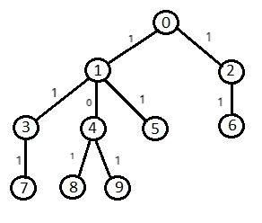

Suppose there are 10 cities in DomKi numbered from 0 to 9 and 9 roads shown in the above picture. The number (***0*** or ***1***) associated with each road determines whether this road is available or not (**Note that**, 0 means the road is not available and 1 means available).

Let there is a group consist of 2 people, numbered with 3 and 5 wants to meet each other. Then there is a set (say S) of 4 different cities they can select to meet which are, ***S = {1, 0, 2, 6}***. The shortest distance from city 3 to each city in S and city 5 to each city in S is identical.

**Note that, city 4, 8 and 9 are also same distance away from city 3 and 5 but they are not reachable.**

Now the task is to count the size of the set ***S*** for a given group of people.